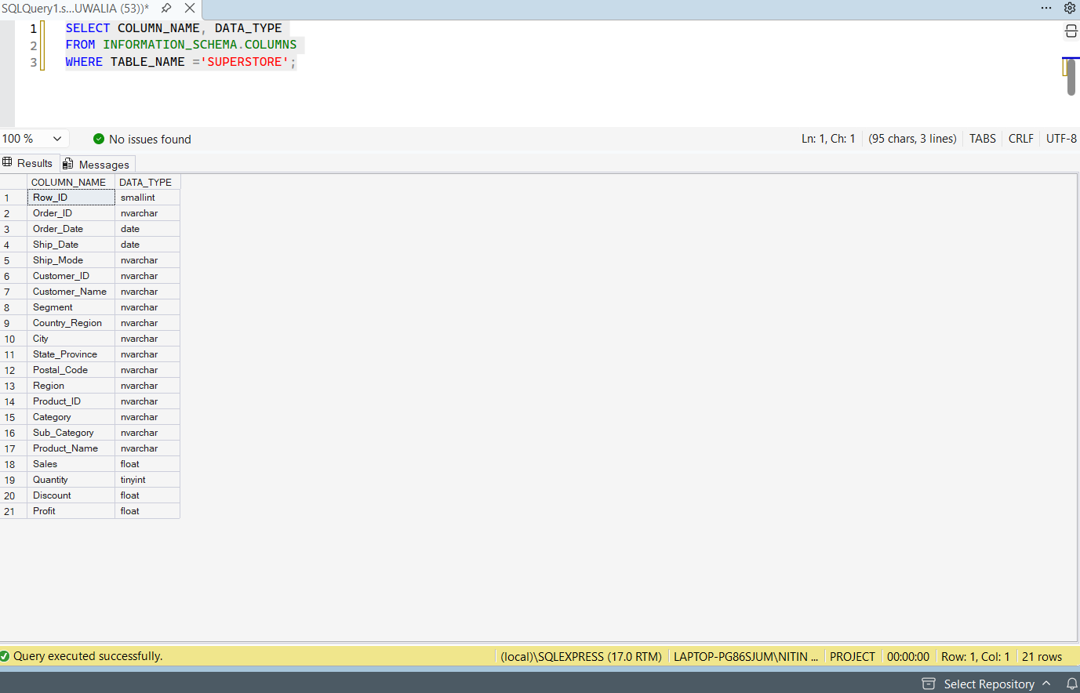
Why: Always look before you query. This confirms the column names and shows whether the dates were imported as text (varchar) or as real dates.
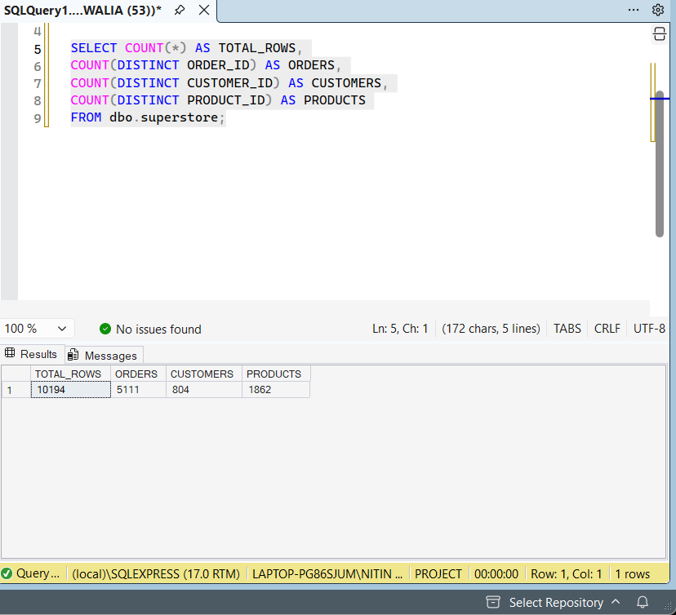
Why: This gives the size of the data. Expected: 10,194 rows, 5,111 orders, 804 customers, 1,862 products. If your numbers differ, some rows did not import, so recheck the import before going further.

